The Orbits
The emitter satellite is injected into a circular orbit (Orbit 1 on the figure 14.2) at an altitude of 500 km. The eccentricity is frozen at 0. Inclination is chosen to be 85 degrees, as this allows access to polar areas, which are places of interest for the mission. Furthermore, the inclination provides an inherent relative phase for the crossing orbits. The Right Ascension of the Ascending Node can be chosen arbitrary for the start of the mission, as no specific target is assumed for the mission. For consistency, in all following discussions it is assumed to be 0 degrees. The same goes for the Argument of Perigee and the True Anomaly. As the orbit is circular, these values are not really relevant. The emitter satellite acts as the reference for all the receiver satellites.

Unlike the emitter, the receiver satellites are placed in six different orbits and have to be designed to be able to handle all orbits and yet all the satellites have to have the same mass configuration at all times.

The orbits are divided into primary and secondary. The primary orbits are shown in figure 14.2. Receiver 1 is located in Orbit 3 which has all the same orbital characteristics of Orbit 1 with the exception of RAAN having a value of +2.18 degrees. This is the maximum angle of separation and is derived from the requirement of a laser reflection angle of 30 degrees. Receiver 2 in Orbit 2 on the other hand has a RAAN of -2.18 degrees. Both of these receiver satellites pass their ascending nodes at the same time as the emitter satellite. The reason for this is that the inclination of the orbits induces a relative phase between the satellites which is favourable for collision avoidance. Receivers 3 and 4 are placed on the same orbit as the emitter. Receiver 3 travels with a positive phase offset of 2.18 degrees in front of the emitter, while the latter is trailing the emitter with the same offset.

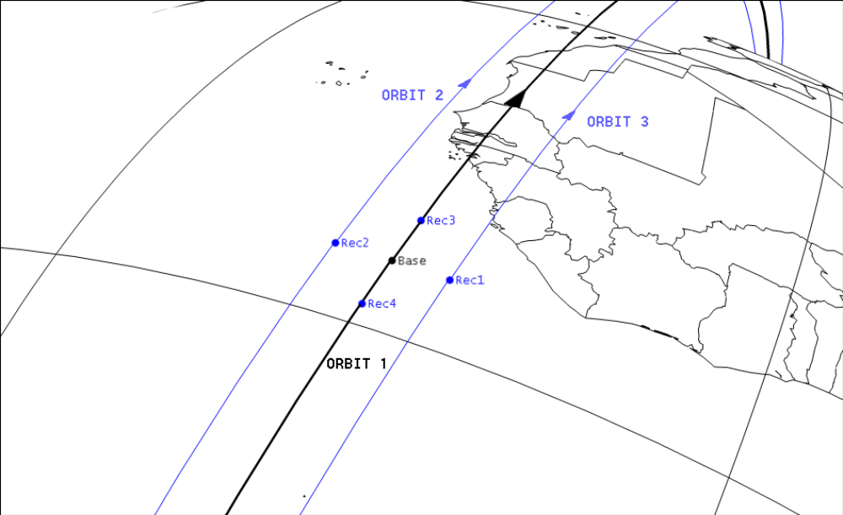
Figure 14.2

